**Practice Question - Week 3 19/07/20 -- 23/07/20**

1. Write a program to take length and elements of a list from the user.  
   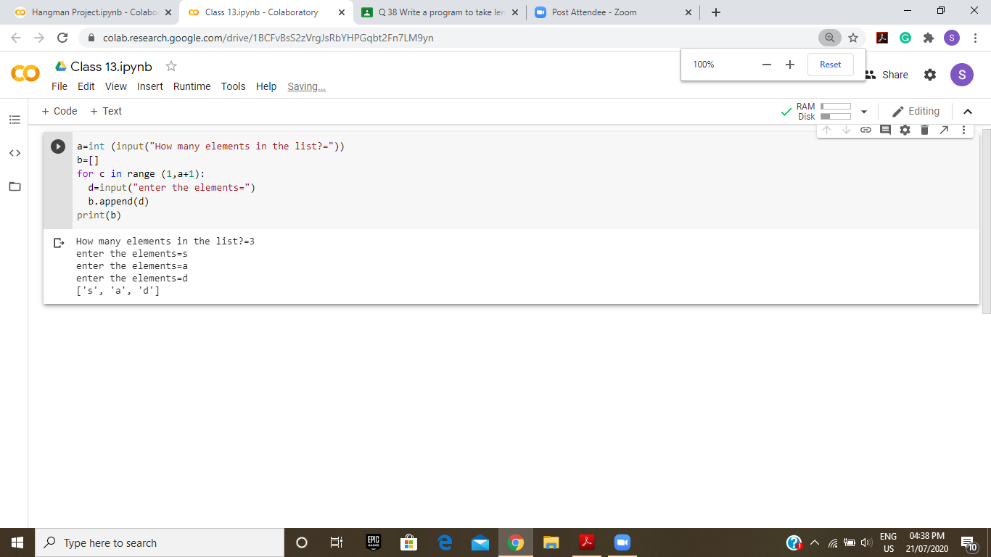
2. Write a program to print fibonacci series.  
   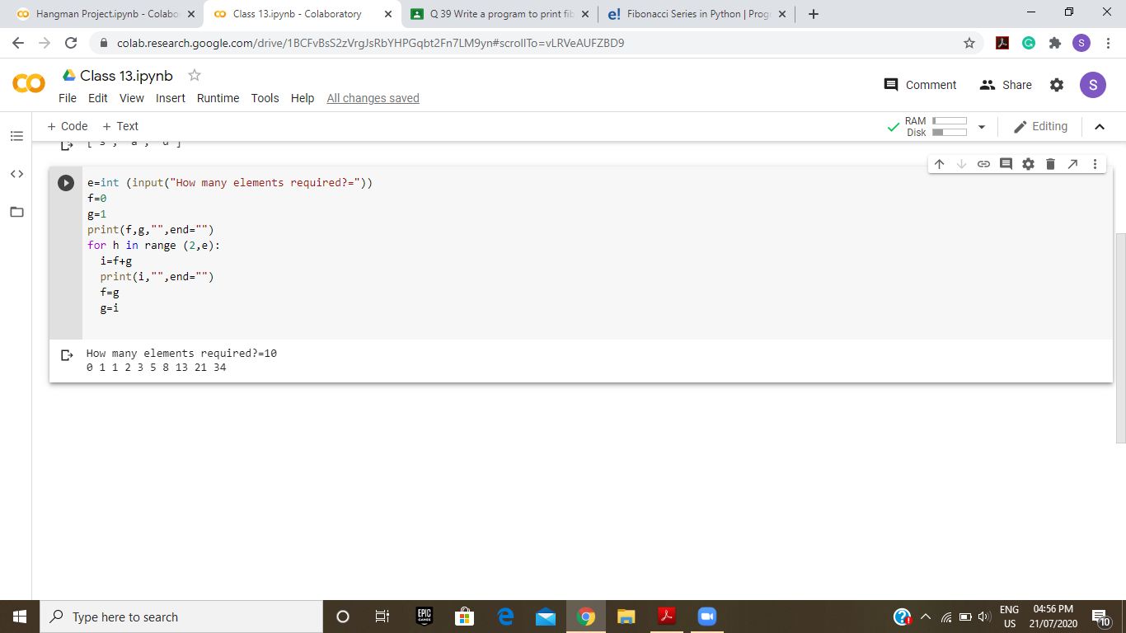
3. Write a Python program to find unique elements in a list given by the user.  
   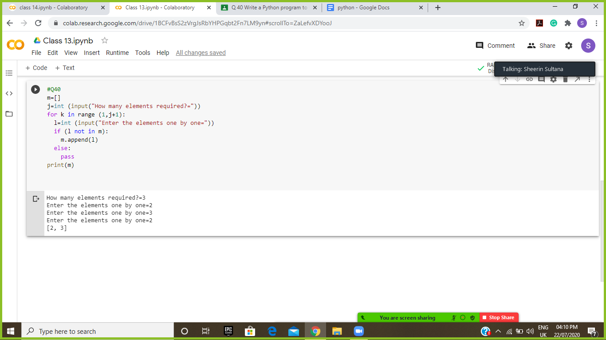
4. Write a python code that takes two lists from the user and returns True if they have at least   
   one common member.  
   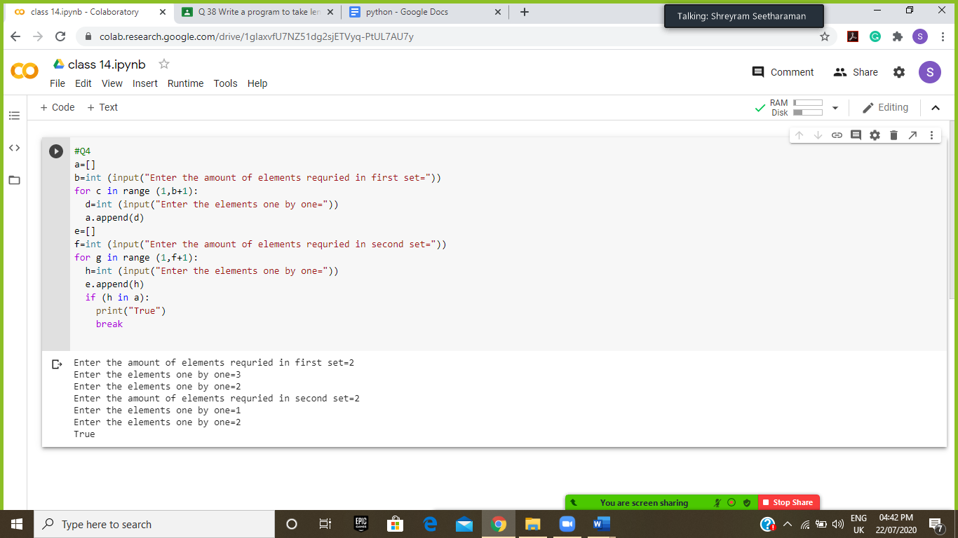
5. Write a Python program to generate and print a list of first and last 5 elements where the values are square of numbers between 1 and 30 (both included).  
   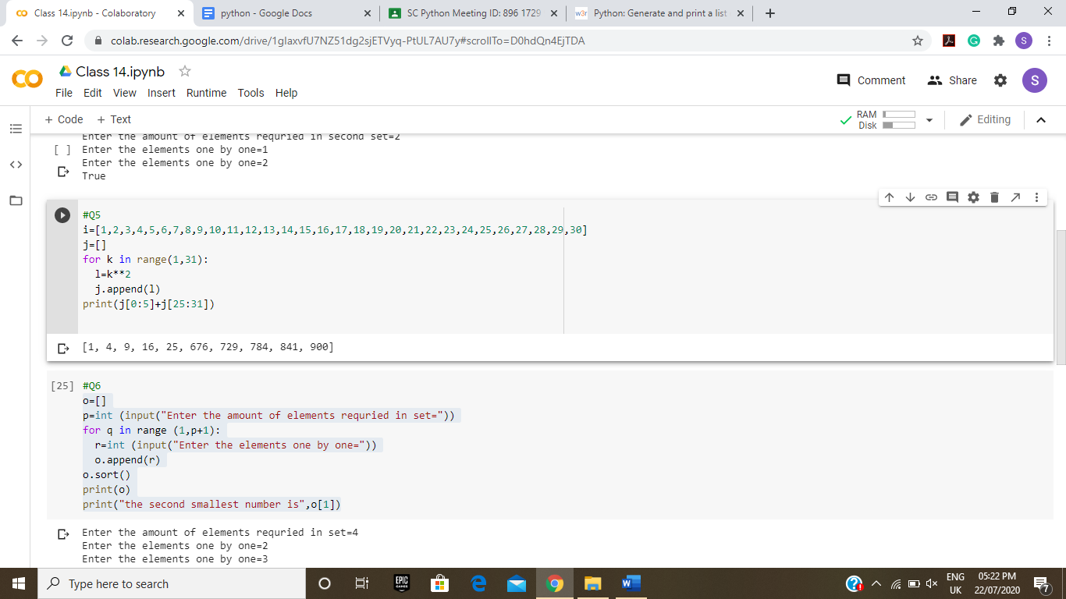
6. Write a Python program to find the second smallest number in a list.   
   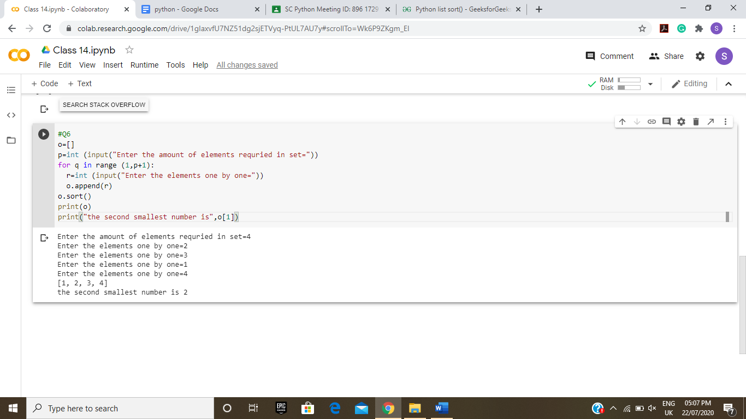
7. Write a Python program to find the second largest number in a list.  
   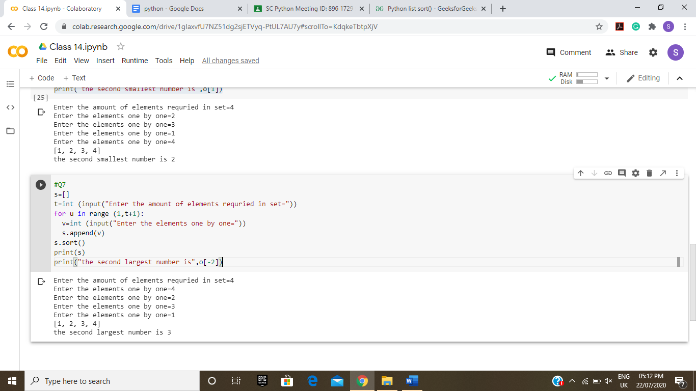
8. Write a Python program to count the number of elements in a list within a specified range given by the user.
9. Write a Python program to check whether a list contains a sublist specified by the user.
10. Write a program that prints out the first n rows of Pascal's triangle.
11. Write a Python program to convert a list of multiple integers into a single integer.
12. Write a Python program to find missing and additional values in two lists.
13. Write a Python program to get the difference between the two lists.
14. Write a Python program to find the list in a list of lists whose sum of elements is the highest. Sample lists: [[1,2,3], [4,5,6], [10,11,12], [7,8,9]] Expected Output: [10, 11, 12]
15. Write a Python program to insert an element at a specified position into a given list.
16. Write a program to generate n rows of pascal’s triangle.